**CommuniKate**

**The Open Page Set**

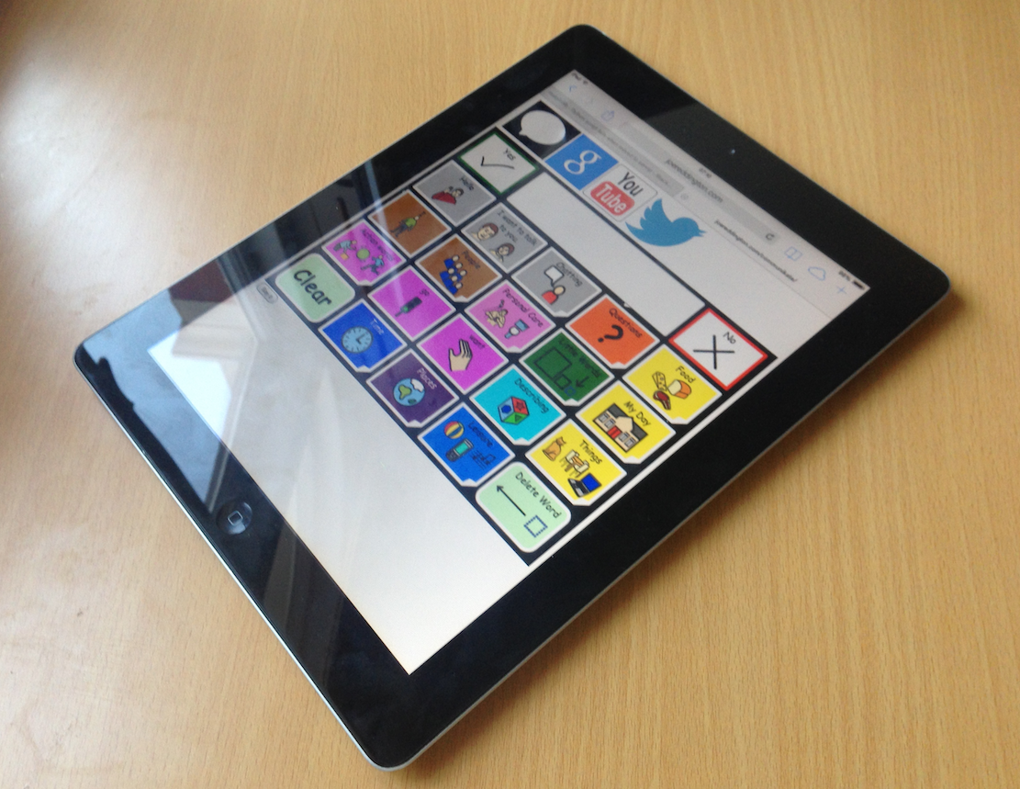

**Dedication**

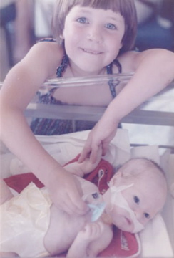

*To my little bro, I have no idea who or what I would be without you. You will never truly understand what you mean to me, that’s ok. You have taught me so much. CommuniKate would never have happened without you. Thank you!*

Kate

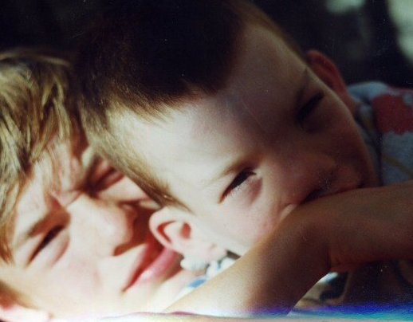

*For Richard, because life would be simpler if I did as I was told.*

Joe

# Document Version history

* Version 1.0: 18/11/14, Dr Joe Reddington and Kate McCallum
* Version 2.0: 2019 Aideen Lynam
* Version 2.1 2022 Dr Joe Reddington

**Acknowledgements**

I was enthused by a discussion group led by Dr Joe Reddington at Communication Matters conference in 2013. During this session he encouraged people to work together and discussed some of the issues facing the AAC field. This talk included an introduction to the possibility of open source approaches to AAC, he really challenged my thinking, as this was something I had previously thought might be a dream to far.

Much of the work to produce CommuniKate 20 has taken place late at night, on long train commutes, and via thousands of emails, Joe, I thank you for your time, endless hours of coding, patience and allowing me to constantly change and challenge what is possible. Your dedication and support to make this dream a reality and make CommuniKate 20 freely accessible has been and continues to be amazing. Thank you for saying “Let’s give this a try!”.

CommuniKate 20 would never have been published without the tireless support of all the people who from the beginning have used it, supported people who use it, helped to sculpt it, and enabled it to evolve into what it is today: thank you.

Janet Scott and the team at SCTCI, Janet when I began working with you I had no idea how steep my learning curve would be. You gave me such an amazing start in the AAC field, the best foundation on which to build my career, thank you for your continued support.

Alison Carpenter, Diana Mountain, Stef Armitage, and Catherine Maunder, you keep me out of trouble on a regular basis, you understand my passion for what we do, and the reason I fight so hard for the people we work with. Zak Sly, Neil Oughton, Rohan and Kathryn Slaughter, Trevor Mobbs, Fil MaIntyre, Sally Featon, and the whole team at Beaumont College. Thank you for everything.

Thank you Dave Morgan for giving me my first start in the manufacturers side of AAC.

Joan Bruno for having me as an intern at Camp Chatterbox, I learnt so much and had so much fun, but I have never drunk as much coffee in my life!

Nancy Inman, Tracy Kovach, Gail Van Tattenhove, and Communication Matters for your inspirational and informative study days.

Founders of 1 Voice: Katie Clarke and Tamsin Crothers, thank you for being simply amazing and all the role models, families and trustees who continue to network and support AAC users and their families all over the UK.

Kate

I owe a debt of gratitude to Kate first and foremost for helping me understand where I wanted to be in the world. For this work, I sucked in good ideas wherever I found them, and I found many: Annalu Waller, Will Wade, Russell Smith, and the staff of a dozen companies were the sounding boards I needed. Mentors are one of the things you think you don’t need and then wonder how you ever lived without; thanks to Dave Whiteland for being mine. Honest friends are the things you wonder how you live *with* but know you need, thank you to Clare Walsh and Emily Dongray for being mine.

Thank you to Nava Tintarev for being my compass that points north. Archimedes called for a solid place to stand and a lever; Peter Moran is the solid ground I stand on. The others that I am proud to stand behind: Hannah Newton for regularly teaching me things I enjoy forgetting, Laura Smith and the group that silence me with stories, Amanda McGrath and the team that taught me that I could lead. I should thank Professors Johnstone and Scott for waiting patiently for me to evolve and my godchildren for needing the awesome now. Lastly, I want to thank Francesca Baker and Sarah Moffat for being two of the best proof-readers I could have.

Joe

**Contents**

Introduction 10

Who is CommuniKate intended for? 10

History of CommuniKate 11

How can I try CommuniKate? 12

What makes CommuniKate different for users? 12

Transferability 14

How CommuniKate helps 16

Sharing 17

How CommuniKate helps 17

Open Source 18

How CommuniKate helps 18

Design and Structure 19

Overview 19

Button Types 20

Colour Coding 20

Optional features 21

Core Words 22

Communicate 20 26

Page List 26

Page Detail 28

CommuniKate 12 31

Page List 31

Page Detail 33

Everyday Use 36

Personalising CommuniKate 36

About Me 37

My Stories 38

Leisure 39

Places 40

People 41

WML 42

Private parts 43

My Day 44

Blank templates for creating a new page 45

Adding Symbols 45

Step Through Guide 47

Phase 1: Introducing Core, (none picture producing) language. 47

Phase 2 49

Phase 3 50

Phase 4 51

Phase 5 53

Low Tech 54

Creating a Low-Tech Book 54

Low Tech Resources 56

Searching for Vocabulary in CommuniKate 57

Translations 58

Further Information 61

CommuniKate Online! 62

What 62

Rights and Licences 63

Icons 63

Page set 64

Screenshots 65

66

This Manual 66

Future Plans 66

Appendices 67

Testimonials 67

68

About the Authors 69

Kate McCallum 69

Joe Reddington 71

References 72

**Table of Figures**

Figure 1: The 'food menu' page from CommuniKate 20 9

Figure 2: Kate's Brother, with his AAC device 10

Figure 3: CommuniKate 20 running in a web browser 11

Figure 4: Joe's little brother with his device. 12

Figure 5 Joe's little brother, wearing climbing equipment that Kate sacrificed from her climbing kit. 15

Figure 6: The 'Top Page' page for CommuniKate 20 18

Figure 7: Range of colours used in CommuniKate 20

Figure 8: CommuniKate 20's Keyboard 20

Figure 9: Core words that are non-picture producing 21

Figure 10: Kate’s brother encouraging her to share his love of Halloween. (Scary) 35

Figure 11: About me page of CommuniKate 20 36

Figure 12: My Stories page of CommuniKate 20 37

Figure 13: Leisure page of CommuniKate 20 38

Figure 14: Places page of CommuniKate 20 39

Figure 15: People page of CommuniKate 20 40

Figure 16: WML page of CommuniKate 20 41

Figure 17: Private Parts page of CommuniKate 20 42

Figure 18: My Day page of CommuniKate 20 43

Figure 19: Template page of CommuniKate 20 44

Figure 20: Front page of a low tech CommuniKate communication book with corresponding tabs 54

Figure 21: 3D printed symbols from the CommuniKate page set. 54

Figure 22: CommuniKate 12 board 55

Figure 23: CommuniKate 20 ICE card 56

Figure 23: Richard getting Joe's attention. Possibly vice-versa 70

# Introduction

The CommuniKate page sets are socially focused page sets designed exclusively for people who use augmentative and alternative communication (AAC). They were designed so that they could be easily used in conjunction with a low-tech communication book and as a progression from a book to a dynamic display device. There are two page sets in CommuniKate– CommuniKate 12 and CommuniKate 20. CommuniKate 20 has a maximum of 20 symbols (plus a message bar and yes/no symbols) on each page, whereas CommuniKate 12 has a maximum of 12. The vocabulary of each page set differs slightly. Please see the ‘Design and Structure’ section for more information.

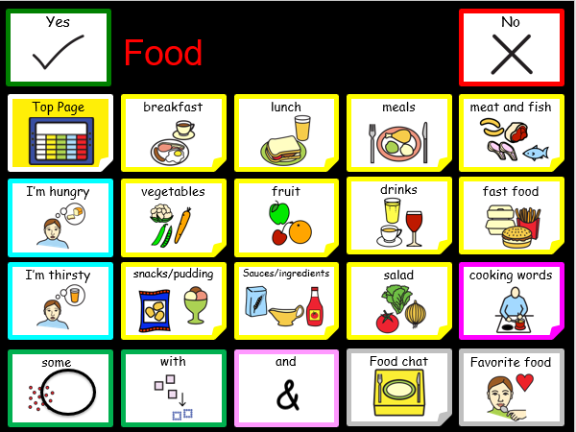

Figure 1: The 'food menu' page from CommuniKate 20

## Who is CommuniKate intended for?

The CommuniKate page sets are designed for people who rely heavily on the environment or context to communicate effectively but understand concepts and language used in conversation and during everyday activities. The CommuniKate page sets support emerging literacy skills and enhance comprehension by using photographs and symbols to represent language. They have been successfully used by people for whom access to many cells is difficult, those with visual needs who require large buttons and text, and those using auditory scanning.

## History of CommuniKate

In 2001 Kate’s brother got his first communication aid. It did not have a page set that was appropriate for him, so she wrote one. This was the beginning of CommuniKate. The original layout had just 12 buttons per page. However, he progressed so quickly that soon 12 buttons did not give him the access to the volume of vocabulary he needed. CommuniKate 20 was written shortly afterwards and over the last decade has been modified and refined to work with the widest possible range of users. In 2014, CommuniKate 20 was formalised and released publicly under an open licence. Since then it’s become the de-facto page set for open AAC software including Cough Drop, Optikey and the Open Voice Factory.

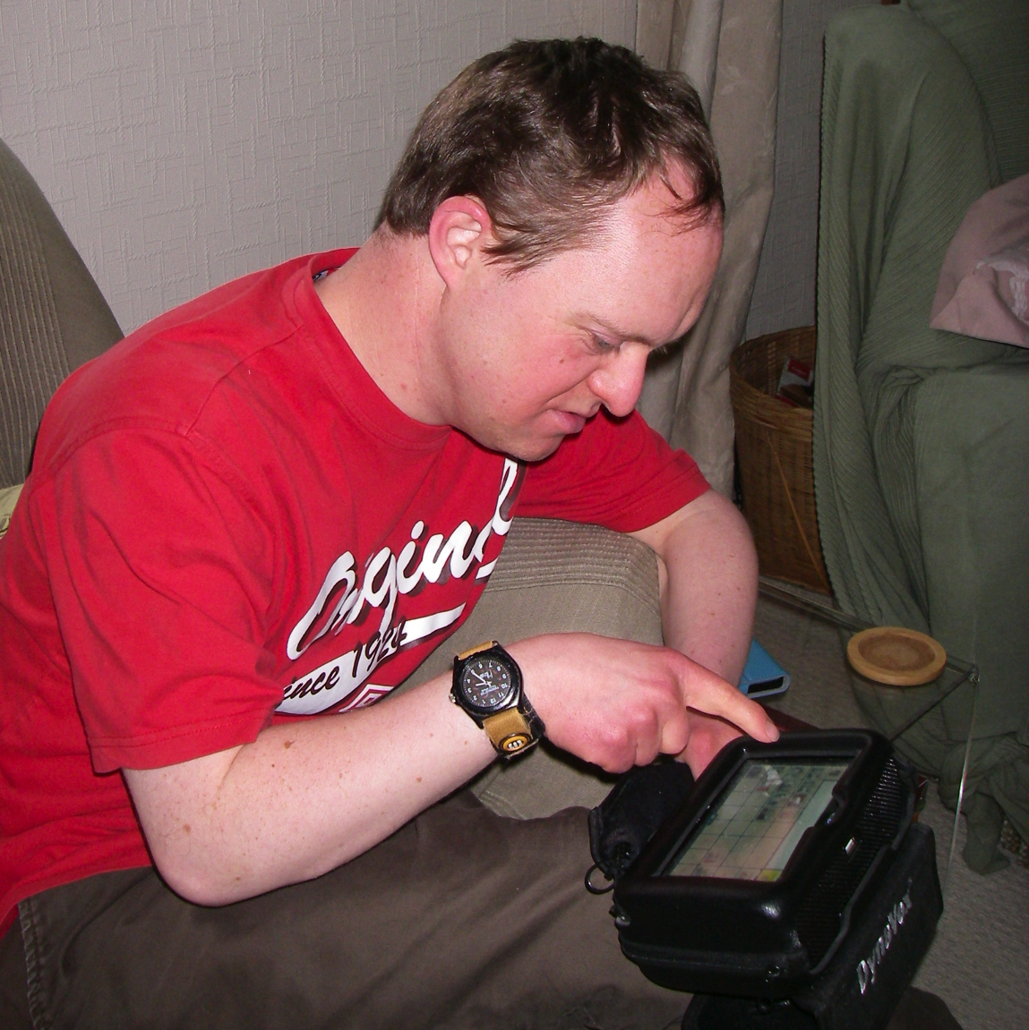

Figure 2: Kate's Brother, with his AAC device

## How can I try CommuniKate?

There are two ways to try CommuniKate. You can try both page sets directly by using the online version through the [Open Voicethe Factory](http://www.theopenvoicefactory.org/)2; for more information on how to use this or how to set up your own version locally see the Open Voice Factory Manual.

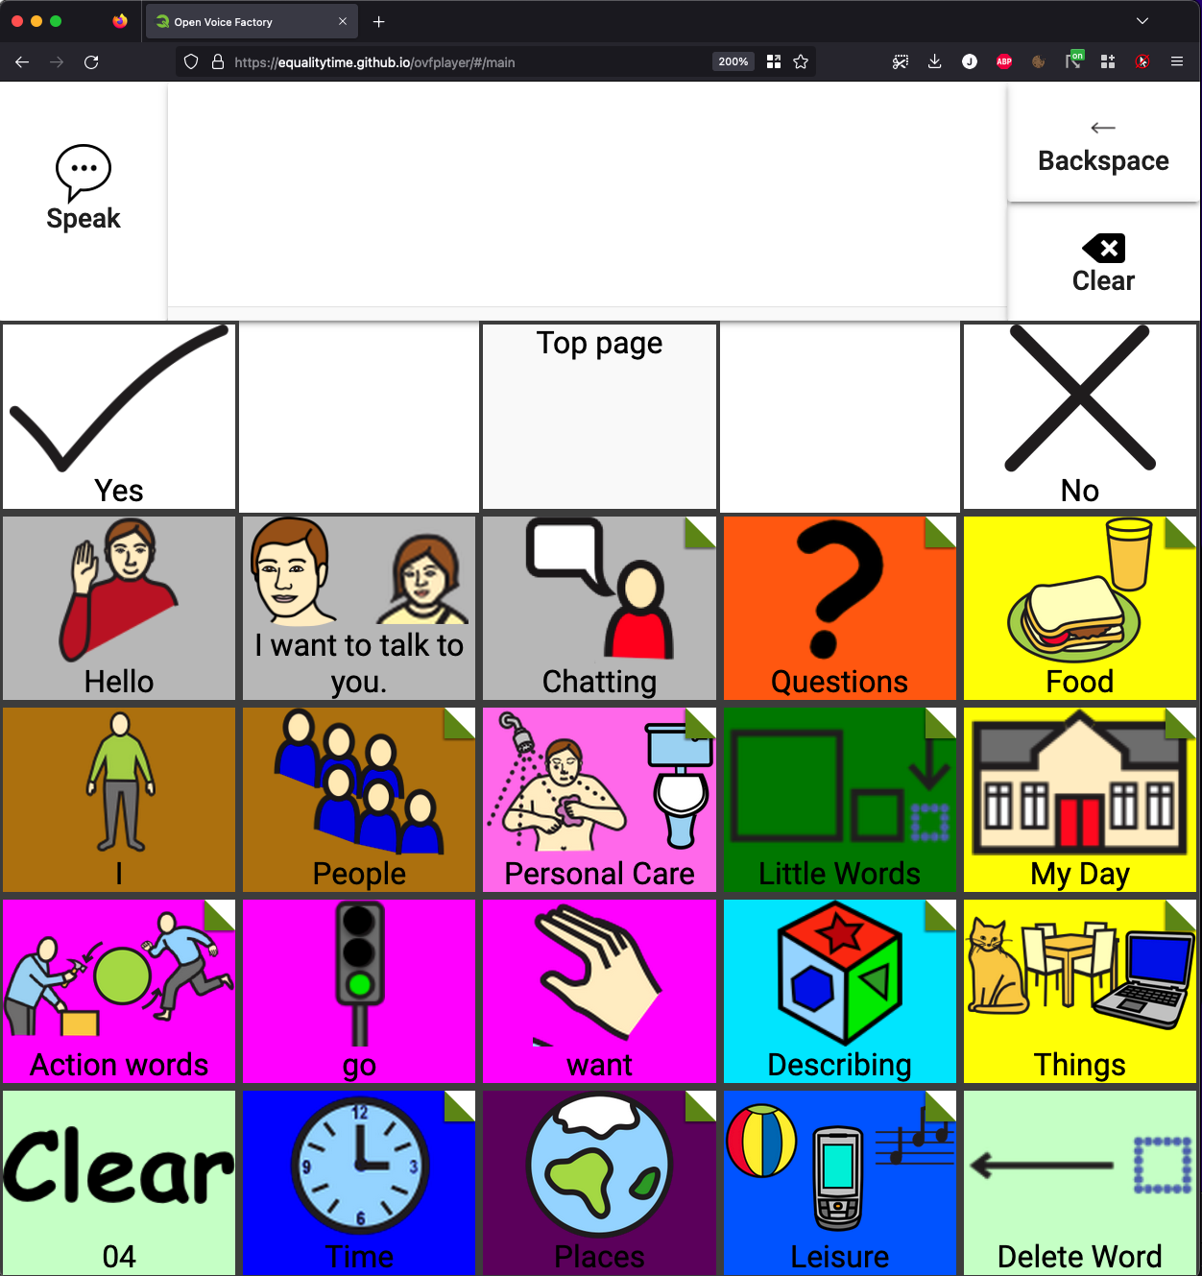

Figure 3: CommuniKate 20 running in a web browser

You can also add CommuniKate to an existing AAC device. [This link](http://communikate.equalitytime.co.uk/)[1] takes you to CommuniKate’s online support. The webpage contains a wide range of materials (including this manual). You can download both the CommuniKate page sets in importable formats for DynaVox Series 5, DynaVox Compass and Grid 2. CommuniKate 12 is also available in importable format for Proloquo2go. CommuniKate 20 is also one of the most popular page sets available in [MindExpress](https://www.mindexpress.be/), and, through the Open Board Format, is available on platforms like [Cough Drop](https://www.mycoughdrop.com/) and [Opitkey](https://github.com/OptiKey/OptiKey/wiki).

## What makes CommuniKate different for users?

CommuniKate 12 and CommuniKate 20 are not only standard page sets, they are entirely free-to-use transferable page sets. This means that there are no legal barriers preventing people from putting CommuniKate 12 or CommuniKate 20 on any device at all. As a result, if you are a CommuniKate 20 user switching to, say, DynaVox, you can download the DynaVox version of CommuniKate 20 and be able to use a familiar page set. The CommuniKate page sets have an open licence under Creative Commons, meaning that they can be altered, shared, reused, and grow- all for free. This section goes into more details about why we believe having open page sets are vital for the AAC community, and how we’ve designed the CommuniKate page sets to best match that need.



Figure 4: Joe's little brother with his device.

## Transferability

As a user’s ‘Voice’, the custom utterances and user history on an AAC device form not only a key part of the user's way of interacting with the world, but often, their memories and sense of self.

Manufacturers recognise that this data is precious and many manufacturers of electronic AAC systems offer the functionality to back up the devices to external storage. However, in the event of irrecoverable hardware failure, such backups are only generally useful if the user's replacement device is of the same model as the existing device (in some cases, manufacturers can transfer backups between different models of the same manufacturer). If it is the case that an AAC device's functional lifespan is longer than the device’s sales lifespan, then it is also the case that massive information loss must occur when a range's devices reach the end of their lifespan and users are shifted onto other devices. Reddington (2014), provides some evidence of the extent of this problem.

***For those wanting an academic perspective on this sort of thing:***

*We consider these to be a counterpart of the work in Deruyter, McNaughton, Caves, Nelson Bryen, and Williams (2007); however, where Deruyter et al. (2007) focused on increased interoperability between AAC and mainstream technologies, we argue in favour of increased interoperability between the devices themselves. The work is perhaps philosophically closer to the work of Lesher, Moulton, Rinkus, & Higginbotham (2000a, 2000b) which seeks to produce universal standards of logging of AAC utterances for research purposes. We argue that a standardised format would also allow technical researchers to develop their prototypes to interface directly with a user's existing systems. This would produce a much more seamless way of testing innovations, without the need to introduce users to dedicated equipment or a specialised app for testing a particular innovation in AAC technology.*

Moreover, because AAC device backups are not held in a common format, it is difficult for AAC users to transfer sets of pages between devices at all. If a user wishes to switch from, say Proloque2go to DynaVox, then the only way to transfer potentially key parts of their identity and memory between the devices is for the user, or care staff, to laboriously recreate systems by hand.

***For those interested in a personal perspective on this sort of thing:***

My brother has had four communication aids so far. Now imagine each time you change aid having to learn a new page set. I could give my bro a similar page set but in my view that’s not fair, it’s like me saying “OK, so for the past 4 years you have spoken French fluently. Well today, I’m taking away that ability and you are going to have to learn German. As if life isn’t tough enough when you have a communication impairment.

Sadly, unless you have someone with the skill set to rewrite your page set, this is the reality. Even when an SLT has been involved, they have either had no programming experience, no time or no desire to implement the programming. So, to avoid him having to relearn a page set, every time he’s had a new device, I programmed CommuniKate 20 into it for him.

Since 2001 that is nine rewrites - no trivial task as depending on the software this can take up to 80 hours each time. I (or someone) could do training with the care staff, but with 6 staff changes in 10 months this is not realistic or a good use of time. Why so much programming? Well, firstly the data backups can’t be transferred or in a few cases, the data might transfer between two very similar devices, but certainly NOT across manufactures. Secondly, just like choosing a car, he needs to test drive the devices on offer before parting with thousands of pounds. Kate

This results in users having difficulties `trying out' new systems, and the occasional sight of a user with two AAC devices: one that is failing but has the full range of utterances, and a more modern device that may be clearer and more effective, but which does not yet have all the necessary utterances. It’s our[2] position that this shows a clear and present need for not only a standardised format for transferring sets of pages between devices but also that this standardised format be open and accessible to researchers.

### How CommuniKate helps

CommuniKate isn’t a complete solution to the transferability problem, but it goes a long way. CommuniKate 12 and CommuniKate 20 are not a format for transferring page sets. However, as they are free to use on any platform, it can make it much easier to switch between devices. For example, if you are currently using CommuniKate 12, and your new AAC device is a DynaVox, then you can download the DynaVox version of CommuniKate 12 from the website[3] and be using a familiar page-set extremely quickly. If a device is broken for a few days, then the [online version](http://www.theopenvoicefactory.org/index.html) can help with basic communication in the meantime. Moreover, if a new AAC device enters the market, CommuniKate 12 only has to be transferred once. Once one person has made the transfer, we can store the device backups online for anyone to make use of. The same applies to CommuniKate 20.

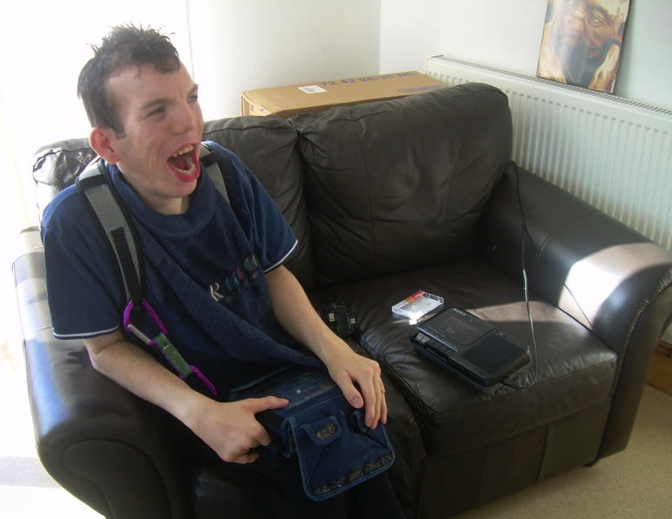

Figure 5 Joe's little brother, wearing climbing equipment that Kate sacrificed from her climbing kit.

## Sharing

Human language evolves culturally rather than individually. The nature of society is such that whole communities take on new topics of conversation at once. At the time of writing Brexit is a major topic of conversation, as is Cheltenham, the Champions League and the prospect of a new royal baby.

There is an acknowledged problem in the AAC community that because of the effort required for new utterances to be added to communication devices, AAC-users are left unable to discuss current affairs. This applies even when such current events arelong running cultural artefacts (the TV-show ‘The Great British Bake-Off’ for example[4]).

Ideally, there would be repositories where users could share language packs and have them easily viewable by other members of the AAC community. These language packs wouldn’t just include current affairs but also any form of special event (‘Christmas’, ‘Weddings’), activity with specialist language (‘Cricket’, ‘Thai cooking’), or any media (‘Yes Minister’, ‘Mr Bean’, ‘GTA5’). Within education this might include relevant packs for lesson plans[5], or the week’s dinner menu.

Some AAC manufactures have made efforts to embrace this approach. Tobii-Dynavox and Smartbox, for example, developed websites devoted to sharing page sets. Unfortunately, this is only for their respective software. In general, not only is it difficult to share the actual files, it is difficult to share images of the file. See the ‘Screenshots’ Section for further information about the problems with screenshots of page sets.

### How CommuniKate helps

CommuniKate and the Open Voice Factory[6] have been carefully designed with sharing in mind. The open licencing structure we have used (See the Rights and Licences section) allow users to both freely modify existing page sets (because the arrangement of the pages is openly licenced) but also display those changes easily (because the layout and colour schemes are also openly licenced). By encouraging users, therapists and assistive technologists to release their work freely, the whole area can benefit from the countless hours of investment that are put into page set design.

## Open Source

The AAC field has many manufacturers but lacks an open-source solution. This is particularly odd because the Open Source/collaborative design movement is well established and exists in almost every category of software. Indeed, in many cases (for example, Wikipedia, Reddit, and WordPress) the open-source solutions dominate their commercial competitors.

In 2014 we wrote:

However, AAC lacks an established open-source solution, in part because it has not had a fully designed and tested page set to work towards. An open source AAC device must have an open licenced page set to work on or risk legal consequences.

…and we are pleased to revise it.

In 2022 there have been significant strides towards a more open ecosystem. The online AAC device Coughdrop released their board format as the Open Board Format, which we swiftly adopted. The eye-tracking software Optikey has an AAC mode and is entirely open source. It was originally text-only but a volunteer added the ability to import boards using the Open Board Format, and a great many people have been able to access CommuniKate by that route.

This is exactly how Open Source systems are meant to work – different groups building on each other’s successes to build combinations that nobody could have alone. In particular, when we created CommuniKate used the open-licenced Mulberry Symbol Set so we didn’t need to create our own symbols.

### How CommuniKate helps

Indeed, the CommuniKate page sets, specifically CommuniKate 20, were the first properly open page set. CommuniKate has an open licence and is available in a machine-readable format. Because of this, CommuniKate is easy for programmers to use as a starting point, allowing them to test their systems and develop further.

In 2014 we wrote:

For example, [The Open Voice Factory](http://www.theopenvoicefactory.org/index.html) is a minimalist open source viewer for page sets, such as the CommuniKate page sets, although it can be retargeted and improved by any programmer.

And it’s pleasing to say that in 2022 The Open Voice Factory is a fully functional AAC device precisely because it **was** retargeted and improved by several excellent programmers.

We appreciate that this aspect may well be less relevant to SLTs on the front line and families who are working hard to get communication for their loved one – we certainly understand that. But we include this here for completeness and because we believe that working towards having an open source AAC solution will improve countless people’s lives in the future, particularly in the developing world.

# Design and Structure

CommuniKate are hierarchical page sets, focused on a *Top Page (*See Figure 6 for an example of CommuniKate 20)that links, by means of symbols and photographs, to a range of subpages categorised by semantics, carrier phrases, or sentences. It contains functional core words and motivational vocabulary, which is essential to support AAC users.

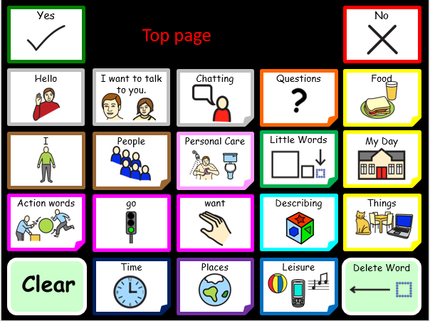

Figure 6: The 'Top Page' page for CommuniKate 20

## Overview

Consistency is key in the design of a page set allowing a user to navigate easily and begin to use Language Acquisition through Motor Planning (LAMP) techniques (Dukhovny & Gahl, 2014; Halloran, 2006; Thistle, Holmes, Horn, & Reum, 2018). In the CommuniKate page sets every page links back to the Top Page and the Top Page button is always in the same place. This consistent design is also keyguard friendly.

The vocabulary needs of users change constantly, so CommuniKate includes template pages that can be filled in with language and links that are personal to the user. For more information see the section ‘Everyday Use’.

## Button Types

There are three different types of buttons in CommuniKate:

|  |  |  |
| --- | --- | --- |
| Symbol button |  | These buttons are rectangular and contain words, sentences or carrier phrases. |
| Function button |  | These pale green buttons have rounded corners and perform a function such as clearing the message window or backspace. |
| Link or navigation button |  | These navigate to another page and have a fold in one corner. |

The CommuniKate page sets were deliberately designed so that each button type was distinct in shape, colour and behaviour. We note that, of course, on some platforms, some aspects of the shape cannot be replicated, and slightly different ones will be used.

## Colour Coding

Colour coding has been used for years as a way of supporting learning of different word groups and aiding navigation. Equally it enables the communication partner to easily facilitate Aided Language Stimulation because they are only then looking in the coloured category for the target word. The CommuniKate page sets have a range of semantic categories which follow and expand on the range of colours of Goossens, Crain and Elder (1992).

See Figure 7 for the range of colours used in the CommuniKate page sets. For example, yellow is nouns, orange is questions, brown is people/pronouns, light blue is adjective, purple is places and dark pink is verbs.

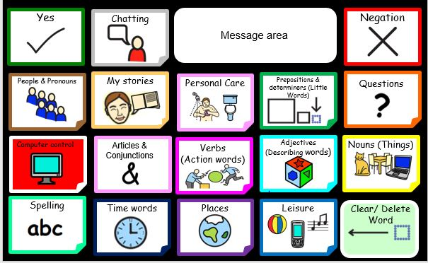

Figure 7: Range of colours used in CommuniKate

## Optional features

Kent-Walsh and Light (2003) indicate most users of AAC devices experience difficulties in literacy development and problems may persist into adulthood. CommuniKate 20 contains a keyboard to encourage scribble writing and emerging literacy skills as well as facilitate any literacy interventions. Letters can be capitalised by selecting the shift button, as seen in Figure 8. CommuniKate 12 does not include this feature.

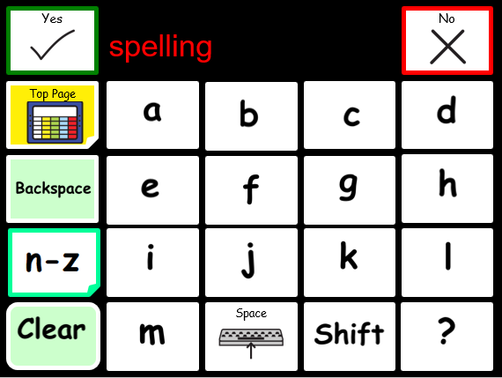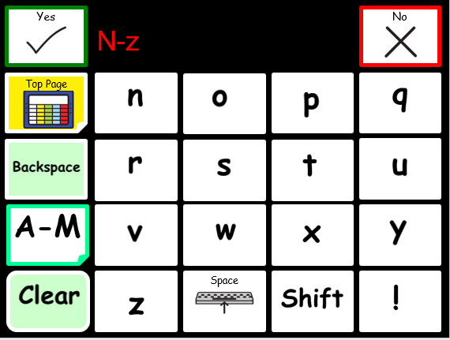

Figure 8: CommuniKate 20's Keyboard

## Core Words

The 100 words we most frequently and commonly say account for around 50% of words spoken in the English language (Kucera and Francis, 1967). *Core words* are important for carrying meaning, but they are not always recognised as important possibly because it is not easy to produce a picture for these words.

 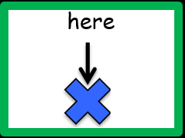

Figure 9: Core words that are non-picture producing

Many core words cannot easily be represented by a picture. Figure 9 shows the symbol for ‘here’ as an arrow and a cross, which for the non-reader requires a certain level of word knowledge and representational understanding to interpret. Similarly, sentences cannot easily be represented by a picture. Hence, many individuals will require some teaching to effectively use these words.

CommuniKate has been designed to give access to a high percentage of core words, enabling them to give clearer meaning to their utterances. Gail Van Tatenhove, SLP, produced a Core Vocabulary List for Students with Intellectual Disabilities (2011). CommuniKate 20 includes 198 of the 227 words in this list. CommuniKate 12, due to the lesser number of pages and symbols, has 115 of the 227 core words. Some words have been substituted for more common words in the British-English dialect, such as woman to lady, mad to angry, and aide to PA. Some of the core words that have not been counted as being present in CommuniKate, are actually present in the form of a sentence, just not an individual word – for example ‘I am hungry’, ‘to call someone’, ‘my name is’. Of course, if required, these can be added in as individual words when personalising the vocabulary. See section on ‘Personalising CommuniKate’ for more information.

CommuniKate 20 contains all the core words identified by Banajee, DiCarlo and Stricklin (2003). Banajee et al. studied the frequency of vocabulary used by toddlers and found that the 23 words shown in Table 1 accounted for 96.3% of the words spoken. CommuniKate 12 includes 18/23 core words identified. It does not include the words that, the, a, is and all.

|  |  |  |  |  |
| --- | --- | --- | --- | --- |
| 9.5% | 8.5% | 7.6% | 5.8% | 5.2% |
| 5.0% | 4.9% | 4.9% | 4.9% | 4.6% |
| 4.4% | 3.8% | 3.2% | 3.1% | 2.8% |
| 2.7% | 2.7% | 2.6% | 2.4% | 2.3% |
| 2.3% | 2.1% | 1.0% |  |  |

Table 1: Word frequencies found by BanajeeConversation Scaffolding Support

The CommuniKate page sets have been designed to facilitate conversational flow wherever possible.

User: Top Page→Personal Care → “I don’t feel well”

*This takes the user to the ‘I don’t feel well’ page.*

Partner “Oh dear what’s wrong?”

User: **“I have a pain in my…”**

*This keypress both adds the utterance “I have a pain in my” to the message window and also automatically opens the ‘body parts’ page, so that the user can complete the sentence conversationally.*

Example 1: User keypresses when reporting illness.

Example 1 shows a conversation between a CommuniKate 12 user and their conversational partner and Example 2 shows a conversation between a CommuniKate 20 user and their conversational partner. These examples demonstrate CommuniKate conversational scaffolding. This approach is used in several places in the CommuniKate page sets and is supported by the Open Voice Factory framework used online.

User: Top Page → Food and drink page → “I’m thirsty”*.*

Waiter “What would you like to drink?’

User: Drinks → “Smoothie” button navigates to the flavours page

*This keypress both adds the utterance “Smoothie” to the message window and also automatically opens the ‘favours’ page, so that the user is in a naturally following part of the page set.*

Waiter: “Which smoothie would you like?”

User: Strawberry *navigates back to drinks page*

Water; “What size would you like?”

User: (From drinks page) → describe → medium

Example 2: A CommuniKate 20 user ordering a drink

## Communicate 20

### Page List

* About me
* About you
* Action words
* Alcohol
* Animals
* Art things
* Birds
* Breakfast
* Body Parts
* Chatting
* Christmas
* Clothes
* Colour
* Common things
* Computer
* Cooking words
* Days
* Describing
* Describing drinks
* Drinks
* DVD’s
* Education staff
* Family
* Farm animals
* Fast food
* Feelings
* Fizzy drinks
* Flavour
* Food
* Food chat
* Friends
* Fruit
* Furniture
* Gardening
* General message
* Home
* I don’t feel well
* Insects
* Job
* Juice
* Kitchen equipment
* Leisure
* Little Words
* Lunch
* Materials
* Meals
* Meat and fish
* Milkshake
* Money
* Months
* More Action Words
* MP3
* Music
* My Day
* My stories
* Nature
* Numbers
* Office
* Opposites
* Outside
* People
* Personal care
* Pet care
* Pets
* Photo Album
* Places
* Position words
* Potato
* Private parts
* Questions
* Salad
* Sauces
* School/work friends
* Shapes
* Shops
* Snacks/Puddings
* Special days
* Spelling
* Spelling 2
* Spelling Caps
* Spelling Caps 2
* Sports
* Support staff
* *Template Page
* Things
* Things that help
* Time
* Toiletries
* Tools
* Top page
* Toys
* Transport
* TV channels
* Vegetables
* Want
* Water animals
* Weather
* Wild animals
* Work things
* WML
* Yet more action words

### Page Detail

The Top Page of CommuniKate 20 links to a range of semantic categories, many of which have further links to pages relating to the category. This section describes the designs decisions that informed the page layout.

|  |  |
| --- | --- |
|  | *Chatting:* - contains a selection of interjections and manners to enable the user to comment (e.g. please, ok, so, I’m fine). This category further links to: *About Me* – which links to *- Tell me about you.* It also links to - *My Stories* and to – *WLM.*  ***Example Link Pages:***  *About me: -* Is a template page in which the user can add as much or a little detail as they wish to share. (e.g. My name is…, I live with…)  *WML:* - Stands for Whatever, Minga, Looser, a page of statements such as: “You’re doing my head in” and “rubbish”. Enabling the user to quickly comment or express an opinion.  *Tell me about you: -* mirrors the *About me* page allowing the user to find out personal information about someone else. (e.g. What’s your name?, How old are you?)  *My Stories:* - Opens to a template page designed to be personalised for the individual using CommuniKate with stories and memories they wish to share.    *NOTE:* Please see section on personalising CommuniKate. |
| **?** | *Questions: -* Contains question words, and commonly used question sentences. (e.g. what, when, who & What have you been doing?) |
|  | *Food: -* Contains some core words (e.g. some, more and) and phrases relating to food (e.g. I’m hungry, I’m thirsty). It links to a large range of semantic categories relating to food: |
|  | *People:* - Contains common pronouns (e.g. I, you, he, they) and links to a set of template pages, *friends, school/college/work mates, support staff, education staff* and *family*. It also links to *jobs* page. |
|  | *Personal Care: -* Provides a guide to the type of phrases the user may wish to convey. (e.g. I’d love a bath, I need to get changed). It links to *clothes, toiletries, body parts,* which further, links to *Privet parts*. It also carrier phrases such as “*I don’t feel well”*, which links to a *Health problems page*.  ***Example Link Page:***  *I don’t feel well: -* Opens to common health related problems which arepredominately positioned in the same places as the ‘*body parts’* e.g. “headache” is in the same position as “head”, “stomach ache” is in the same position as stomach. |
|  | *Little words:* - Opens to articles, prepositions and conjunctions (e.g. all, to, is, the). |
|  | *My Day:* - Is a template page designed to be personalised for the individual user with links to pages specifically relating to their day. Additionally, it also links to *timetable*, *keyboard and numbers* pages. The link to a *computer access* page will differ depending on the platform CommuniKate is used on. |
|  | *Action Words:* - Opens to a page of high frequency Action words (verbs) and two additional pages for more high frequency verbs.  (e.g. do, stop, like, take, have, try, feel.) |
|  | *Describing:* - Opens to a page of high frequency adjectives (e.g. more, right, different, favourite) and links to pages - *Feelings, colours, shapes and opposites* |
|  | *Things:* - Opens to a range of semantic categories *(Tools, Furniture, Toys)* some of which have sub menus such as Nature which opens to: *Animals:* which links to *Pets, Farm animals, Birds* and so on… |
|  | *Time*: - Opens to a range of high frequency time related words (e.g. today, later, morning, after, again, now) and links to *Days, Months* and *Special days.* |
|  | *Places:* - Opens to a range of generic places (e.g. Town, hospital, pub) and provides links to *‘Shops’* and to ‘*Outside Places’* |
|  | *Leisure:* - Opens to a page of optional links such as: *Photo album, phone page, MP3,* *DVD player,* *Environmental controls (ECU)* and *My Stories*. It also contains a volume control for the user to enable them to make their voice louder or quieter depending on their personal preference and their environment.  The remaining pages link to template pages, which are designed to be personalise for the user. |

## CommuniKate 12

CommuniKate 12 is a simpler version of CommuniKate 20. It has 12 symbols on the screen at any one time, as well as a message bar and yes and no symbols. There are some differences in the vocabulary of both page sets, however the vocabulary can be altered as necessary to suit the needs of the CommuniKate user.

### Page List

* About me
* About you
* Action words
* Alcohol
* Animals
* Art things
* Birds
* Breakfast
* Body Parts
* Chatting
* Christmas
* Clothes
* Computer
* Cooking
* Days
* Describing
* Describe drinks
* Don’t like
* Drinks
* DVD
* Family
* Farm animals
* Fast food
* Feelings
* Fizzy drinks
* Flavour
* Food and drink
* Food chat
* Friends
* Fruit
* Furniture
* Gardening
* General
* I don’t feel well
* Insects
* Job
* Juice
* Kitchen things
* Leisure
* Like
* Little Words
* Lunch
* Materials
* Me things
* Meals
* Meat
* Milkshake
* Money
* More Action Words
* MP3
* My Day
* My day places
* My stories
* Nature
* Numbers
* Opposites
* Outside places
* People
* People who help
* Personal care
* Pet care
* Pets
* Places
* Places at home
* Private parts
* Questions
* Shapes and colours
* Shops
* Snacks and puddings
* Special days
* *Template Page
* Things
* Things that help
* Time
* Toiletries
* Top page
* Toys
* Transport
* Vegetables
* Want
* Water animals
* Weather
* Wild animals
* WML

### Page Detail

The Top Page of CommuniKate 12 links to a range of semantic categories, many of which have further links to pages relating to the category. This section describes the designs decisions that informed the page layout.

|  |  |
| --- | --- |
|  | *Chatting:* - contains a selection of interjections and manners to enable the user to comment (e.g., ok, sorry, I’m fine). This category further links to: *About Me* – which links to *- Tell me about you, I like,* and *I don’t like.* It also links to - *My Stories* and to – *WLM.*  ***Example Link Pages:***  *About me: -* Is a template page in which the user can add as much or a little detail as they wish to share. (e.g. My name is…, I live with…)  *WML:* - Stands for Whatever, Minga, Looser, a page of statements such as: “You’re doing my head in” and “rubbish”. Enabling the user to quickly comment or express an opinion.  *Tell me about you: -* mirrors the *About me* page allowing the user to find out personal information about someone else. (e.g. What’s your name?, How old are you?)  *My Stories:* - Opens to a template page designed to be personalised for the individual using CommuniKate with stories and memories they wish to share.  *NOTE:* Please see section on personalising CommuniKate. |
|  | *Questions: -* Contains question words, and commonly used question sentences. (e.g. what, when, who?) |
|  | *People:* - Contains common pronouns (e.g. I, you, it) and links to a set of template pages, *friends, people who help,* and *family*. |
|  | *Personal Care: -* Provides a guide to the type of phrases the user may wish to convey. (e.g. I’d love a bath, I need to get changed). It links to *body parts,* which further, links to *Private parts*. It also carrier phrases such as “*I don’t feel well”*, which links to a *Health problems page*.  ***Example Link Page:***  *I don’t feel well: -* Opens to common health related problems which arepredominately positioned in the same places as the ‘*body parts’* e.g. “headache” is in the same position as “head”, “stomach ache” is in the same position as stomach. |
|  | *Little words:* - Opens to articles, prepositions and conjunctions (e.g. up, and, there). |
|  | *My Day:* - Is a template page designed to be personalised for the individual user with links to pages specifically relating to their day, for example places they go and hobbies e.g. cooking. Additionally, it also links to *numbers* and *timetable.* The link to a *computer access* page will differ depending on the platform CommuniKate is used on. |
|  | *Action Words:* - Opens to a page of high frequency Action words (verbs) and an additional page for more high frequency verbs.  (e.g. go, want, look, have.) |
|  | *Describing:* - Opens to a page of high frequency adjectives (e.g. more, right, different) and links to pages - *Feelings, shapes and colours, and opposites.* |
|  | *Things:* - Opens to a range of semantic categories *(Clothes, Furniture, Things that help)* some of which have sub menus such as Nature which opens to: *Animals:* which links to *Pets, Farm animals, Birds* and so on…  ***Example Link Page:***  *Food: -* Contains some core words (e.g. some, more and) and phrases relating to food (e.g. I’m hungry, I’m thirsty). It links to a large range of semantic categories relating to food. |
|  | *Places:* - Opens to a range of generic places (e.g. Town, cinema, pub) and provides links to *‘Shops’* and to ‘*Outside Places’* |
|  | *Leisure:* - Opens to a page of optional links such as: *Photo album, phone page, MP3,* *DVD player,* and *Environmental controls (ECU)*. It also contains a volume control for the user to enable them to make their voice louder or quieter depending on their personal preference and their environment.  The remaining pages link to template pages, which are designed to be personalise for the user. |

# Everyday Use

In ideal circumstances any user of AAC would be supported by an AAC assessment team. Unfortunately, due to funding issues, and assessment delays, we are aware of a large number of users, families, and other support setups that are having to make their own way forward in providing access to communication. We are particularly aware that for users outside the UK, there are often no professional services available at all. This section outlines those parts of our experience that might be of interest to people who are isolated from professional support. This should, of course, be in no, way considered professional advice. It also includes some details about pragmatically using the CommuniKate page sets.

## Personalising CommuniKate

Every person who uses AAC has different needs, wants and interests. Editing the chosen CommuniKate page set to customise and personalise for each individual is essential. Personalising a device can provide motivation for the user to communicate through the device. Motivation is a very important consideration when it comes to device use. When motivation to communicate is high, a user is more likely to try to overcome any difficulties in using the device, however, when motivation is low, they may be overwhelmed and instead may decide to forego many communication opportunities (Light & McNaughton, 2014).



Figure 10: Kate’s brother encouraging her to share his love of Halloween. (Scary)

There are two types of edits that should be performed, firstly there are standard phrases which need personalising before full time use. This includes such things as finishing phrases like *"I live in..."* on the about me page. Secondly there are longer-term edits that reflect the changing needs of the user, such as adding the names of new care staff. The CommuniKate page sets contain a number of empty buttons and a series of blank/template pages, intended for exactly this customisation. Ideally this editing should be done with the user to promote ownership of the program and aid location and learning of the new vocabulary being stored.

We suggest the following pages are personalised for the CommuniKate user:

### About Me

Should be personalised to reflect the person using the device, it can be filled in with as much detail as the user wishes to share. It’s important to consider the user’s ability and understanding of the disclosure of personal information. For example, for some users, it may be best to add utterances such as: “I live in Sunnyside” rather than disclosing a full address and postcode.

#### 

Figure 11: About me page of CommuniKate 20

### My Stories

We all have a collection of stories or memories of events that we like to talk about. We call upon these stories at different times. We feel AAC users should have the same ability hence the ‘my stories’ page is intended to be filled with personal stories the AAC user may wish to share, e.g. “Once whilst I was sailing on my friend’s boat, we were out at sea. I looked around us and was amazed to see dolphins surrounding the boat. They followed us for ages, it was so special.” NOTE: It’s important to program carefully, e.g. Avoid putting in “It’s my birthday in three weeks’ time”, or “Last week, I went to ……” because ‘Last week’ will soon become ‘Last month, Last year’ and you will need to edit lots more. Instead use, “On my holiday” or “In March 2019, I saw….”

#### 

Figure 12: My Stories page of CommuniKate 20

### Leisure

The leisure page is designed to be personalised for the individual using the CommuniKate page sets with leisure activities or personal interests such as a page dedicated to Thomas the tank Engine Characters, Star Wars or a page relating to Facebook or Twitter. Equally the *MP3,* *DVD player,* and *Environmental controls (ECU)* can be edited as the user desires, but these pages will differ depending on the platform CommuniKate is used on and its capabilities.

We all have a collection of photographs taken with our smart phones and many of us enjoy sharing these and talking about the picture with others. We feel AAC users should have the same ability hence the *Photo Album* can provide a motivating way for a user to initiate a conversation and to share their experiences. CommuniKate provides the user with a template page, which is as easy to construct as a regular page.

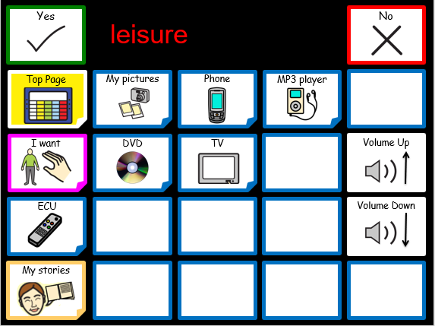

Figure 13: Leisure page of CommuniKate 20

### Places

*My Day* *Places,* is a template page designed to be personalised for the individual user which specifically relates to their day. For example, a day centre or after school club with a specific name would be programmed here. *‘Shops’* and *‘Outside places’* should also be personalised to reflect the places the user is likely to want to talk about; such as Tesco, Sainsbury’s or local pubs or restaurants.

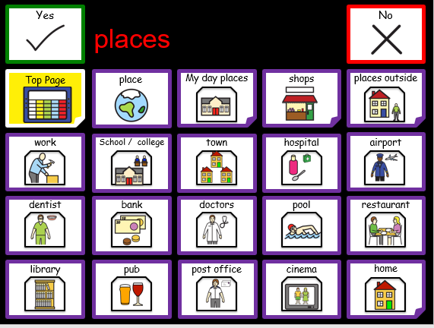

Figure 14: Places page of CommuniKate 20

### People

*People* contains a set of template pages that are intended to be personalised for the individual user. These include, *friends, school/college/work mates, support staff, education staff* and *family.* For many people with disabilities staff are constantly changing and there is a tendency for old staff to be removed/ edited out of page sets. It’s important to remember even though the individual staff member may not work with the CommuniKate user anymore they may still wish to talk about them or reminisce about events that staff member was involved in, hence you may wish to use subcategories to organise this section logically for the CommuniKate user.

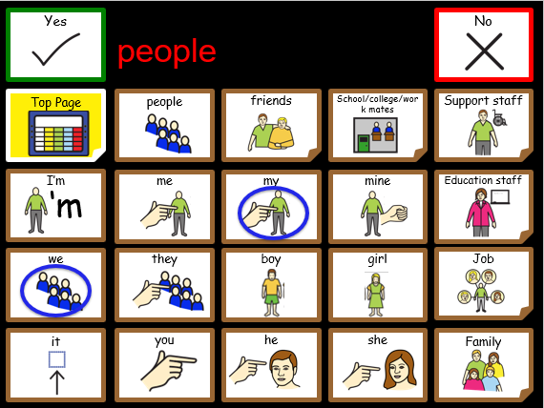

Figure 15: People page of CommuniKate 20

### WML

You will notice yourself when you are chatting with friends, texting or using social media you will commonly use similar words: “Wonderful, awesome, fantastic, ridiculous”. This page is designed to give the AAC used the same opportunity but needs personalising to reflect the users age and personality, e.g. A child may wish to say “Poo, poo, Bottom, and “No way” whereas a teenager/ adult may wish to user more expressive and/or explicit language.

#### 

Figure 16: WML page of CommuniKate 20

### Private parts

The *Private parts page* contains some language which may need editing to meet the age and personal preference of the user.

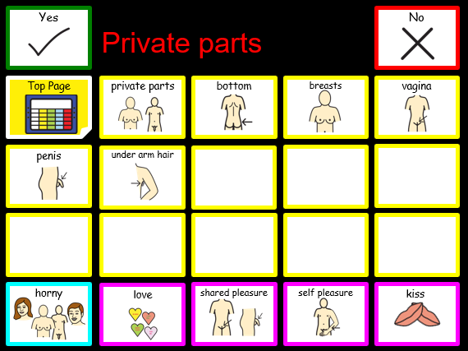

Figure 17: Private Parts page of CommuniKate 20

### My Day

*My day* is a template page designed to be personalised for the individual user with links to pages specifically relating to their day. For example, if the user goes to a day centre and does a specific activity let’s say ‘photography’ it will link to a page with vocabulary relating specifically to this subject. Note that CommuniKate 12 does not include an alphabet page.

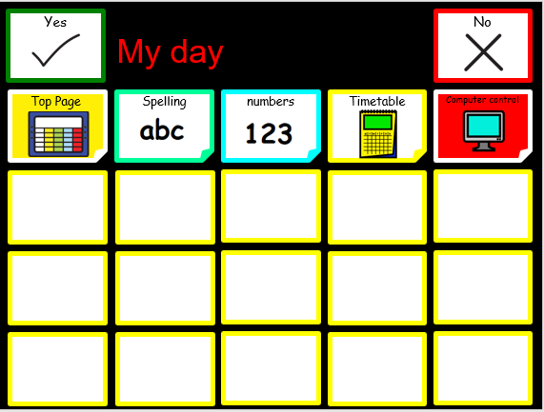

Figure 18: My Day page of CommuniKate 20

### Blank templates for creating a new page

In the background of communicate there are premade template pages to aid quick page creation. It’s important to be consistent in the design and layout of pages to support the users use of the language pack. Equally the colour code should be followed where possible.

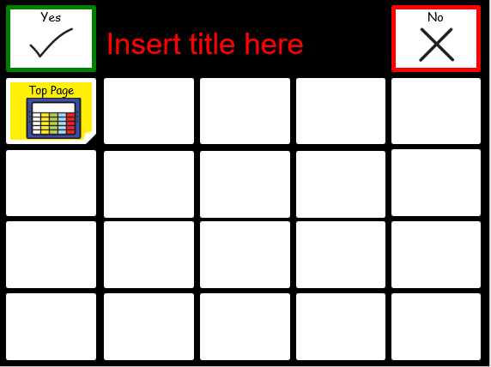

Figure 19: Template page of CommuniKate 20

## Adding Symbols

While it can be natural to think that you should not add symbols/words to an AAC system until the user can clearly demonstrate understanding of the utterances. This has been effectively debunked (Miller, Light & Schlosser 2006; Preston & Carter, 2009; Schlosser & Lloyd, 2003; Schlosser & Wendt, 2008). Without exposure and the ability to use new language, learning the meaning of new vocabulary can be significantly impaired. Aided language stimulation or modelling language are techniques we recommend you explore further to teach language. Equally learning the appropriate context in which to use a word is challenged without exposure to it. Kate has the following parable on the topic.

My three-year-old (typically developing) son is commonly heard producing utterances such as: “Actually, Mummy, you don’t need to worry I’m a professional.” (Usually as he follows his brother on increasingly risky adventures usually involving heights). He has no real understanding of the word “actually” or “professional” but with my support and guidance I can begin to model and teach the meaning of these words and how to use them in context. The same is true of an AAC user, with the correct support many will be able to produce novel utterances independently.

*Equally (as revolting as little boys are and girls to though I’ve not had much experience of them yet) he has been heard shouting “Poo”, (could be worse) over and over again, and yes, as most children do, in the most inappropriate place (usually the most embarrassing of circumstance for me). With my guidance he is learning the appropriate place to say such utterances. (Slowly, I may add, but that’s natural I’m told).* The same is true of an AAC user, with the correct support they too will learn the appropriate place and circumstance in which to use or not use certain utterances.

Kate

## Step Through Guide

This step through guide is aimed at supporting you the communication partner and the user to gain competency and an understanding of CommuniKate.

A key advantage of CommuniKate’s dedication to being open and transferable means for example, even if the user is using CommuniKate on a dedicated device the communication partner can explore CommuniKate on any platform they choose, such as a tablet or iPhone

The communication partner can support a user to learn new words using simple techniques such as modelling where a communication partner demonstrates how to expand utterances to the user. Modelling, or aided language input has been found to facilitate language learning in people who use AAC (Binger & Light, 2007; Dada & Alant, 2009; Sennott, Light, & McNaughton, 2016).

All users are unique and will be at differing language levels. You can, depending on the individual, begin at the start of this guide or jump in at the level that best suits the individual’s language capability. We offer this as a suggestion, ideally, a qualified SLT should design the CommuniKate program for the individual user.

### Phase 1: Introducing Core, (none picture producing) language.

|  |  |
| --- | --- |
| USER *wants an apple.* | |
| USER: |  |
| CP (modelling) |  |

*Here are some further examples for you to try:*

|  |  |
| --- | --- |
| *USER* *wants to go swimming.* | |
| USER: |  |
| CP (modelling) |  |

|  |  |
| --- | --- |
| *USER* *wants to tell Dad something.* | |
| USER: |  |
| CP (modelling) |  |

|  |  |
| --- | --- |
| *USER* *wants to put something in the bag* | |
| USER: |  |
| CP (modelling) |  |

### Phase 2

Once the user is competent linking 2/3 part phrases using core and fringe vocabulary you can then begin to add words by modelling 3/4 part phrases.

Slowly, you can begin to add in negation, some question words and description. You could try these:

|  |  |
| --- | --- |
| *USER* *points at bacon and shakes head.* | |
| USER: |  |
| CP (modelling) |  |

|  |  |
| --- | --- |
| *USER* looks at clock and gestures towards them self | |
| USER: |  |
| CP (modelling) | “?’ |

|  |  |
| --- | --- |
| *USER* looks towards a pint glass and his friend | |
| USER: |  |
| CP (modelling) |  |

### Phase 3

A user who is competent using 3 /4 word sentences can then begin to learn to add in further description and feelings. Try these:

|  |  |
| --- | --- |
| *USER* points to their tooth, which has a new filling. | |
| USER: |  |
| CP (modelling) | “”. |

|  |  |
| --- | --- |
| *USER* looks sadly at the washing machine which contains their t-shirt | |
| USER: |  |
| CP (modelling) | “.” |

|  |  |
| --- | --- |
| *USER* looks at friend who is sleeping on the sofa | |
| USER: |  |
| CP (modelling) | “ ” |

### Phase 4

Once a user begins to use feeling and description in a 4 part phrase you can then begin to teach them reasoning, for example:

|  |  |
| --- | --- |
| *USER* looks at the empty pudding bowl. | |
| USER: |  |
| CP (modelling) | “.” |

|  |  |
| --- | --- |
| *USER* hugs friend that they care about. | |
| USER: |  |
| CP (modelling) | “” |

|  |  |
| --- | --- |
| *USER* looks at shopping bag they got in town on Saturday. | |
| USER: |  |
| CP (modelling) | “”. |

Add in more question words:

|  |  |
| --- | --- |
| *USER* looks at the calendar in their phone | |
| USER: |  |
| CP (modelling) | “,?” |

Add in past and future tense:

|  |  |
| --- | --- |
| *USER* puts the working remote-control car on the ground and smiles. | |
| USER: |  |
| CP (modelling) | “” |

### Phase 5

You can begin to teach how to give, gain and share information, describe situations and add in linking words: What happened or is happening and how did or does it make you feel?

|  |  |
| --- | --- |
| *USER* is excited when he looks at his calendar. | |
| USER: |  |
| CP (modelling) | “” |

Begin to use questioning to gather information about when and how situations happen.

|  |  |
| --- | --- |
| *USER* looks puzzled during a conversation | |
| USER: |  |
| CP (modelling) | “?” |

|  |  |
| --- | --- |
| *USER* hands his smashed laptop to his brother saying: | |
| USER: |  |
| CP (modelling) | “  ?” |

# Low Tech

We can’t stress the importance of having a backup system enough. There are simply times when a Low-Tech backup is essential, for example when your device is broken[7] (a lot can go wrong with a device (Shepard, Campbell, Renzoni and Sloan, 2009)). Some users may prefer to use a low-tech device in different situations, in fact it may be unavoidable, for example when the user is in the bath or the pool! Equally it may be useful for modelling, finding, and familiarising yourself with language if a spare device is not accessible.

## Creating a Low-Tech Book

Many AAC users begin their AAC journey using a communication book before moving on to high-tech AAC. It is very easy to create a low-tech communication book using the CommuniKate page sets, especially as they are free and open-licenced. The master copy of CommuniKate was designed in PowerPoint, hence it’s really simple to make some quick edits, personalise the PowerPoint for the individual and then print off the book and create your own Low-Tech book to use. There is a guide on how to create a low tech communication book using CommuniKate [here](http://equalitytime.co.uk/4604/2015/01/12/step-by-step-making-a-low-tech-communication-book/)8. The guide gives you helpful tips to think about when creating a board, as well as step by step photos of the creation of one such book.

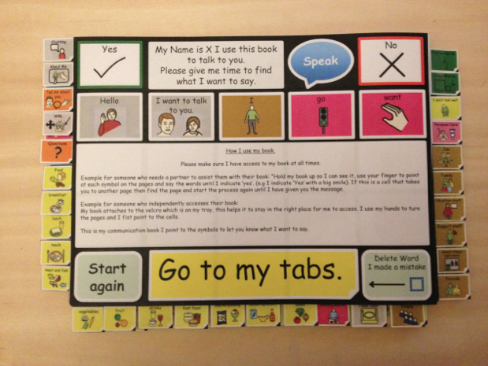

Figure 20: Front page of a low tech CommuniKate communication book with corresponding tabs

Another example of a low-tech resource which can be created using the CommuniKate page sets are 3D printed symbols. These symbols, seen in Figure 21, were created for an individual who had a visual impairment but who struggled to use braille to communicate. As CommuniKate is openly licenced, there is nothing stopping you from experimenting with the page sets to improve the usability for any user.

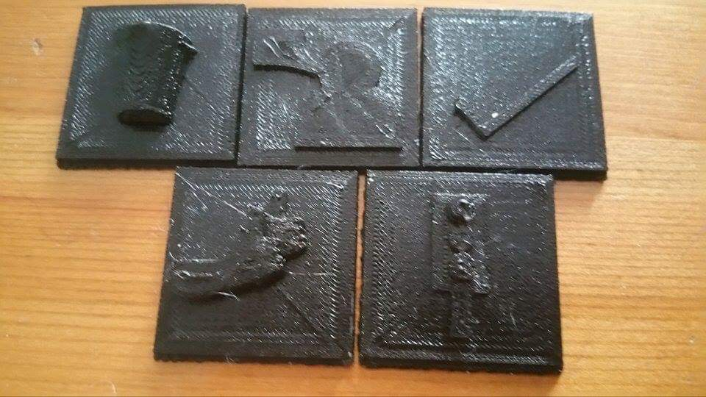

Figure 21: 3D printed symbols from the CommuniKate page set.

## Low Tech Resources

The CommuniKate [website](http://communikate.equalitytime.co.uk/) has other printable low-tech resources which are ready made and freely available. These include large boards which can be printed out in A3 size. These are in PowerPoint format, across two slides, which allows for easy editing of the board. These large boards may be useful for someone who has difficulty navigating the various pages and tabs of a communication book.

They can also be used for clear modelling of language- for example a board can be stuck up in a home or classroom so that it is clearly visible and creates a great opportunity to get everyone in the environment using the CommuniKate board.

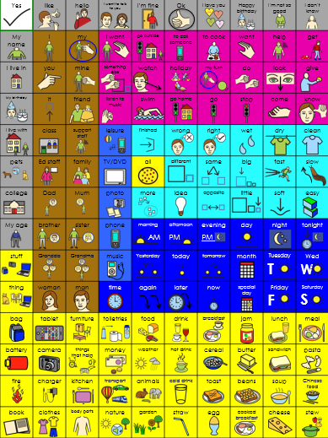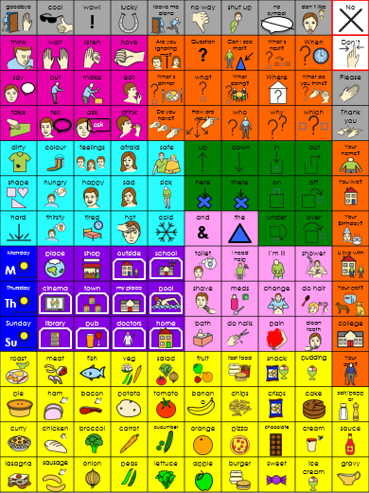

Figure 22: CommuniKate 12 board

Another readily available low tech CommuniKate resource are the ‘In case of emergency’ (ICE) cards. These ICE cards fold up nicely to fit in a pocket and are used, as the name suggests for emergency situations like a medical problem. The normal CommuniKate content has been altered to put medical matters first. It is recommended to personalise the ICE card, which can be completed through PowerPoint software once it has been downloaded from the [website](http://communikate.equalitytime.co.uk/).

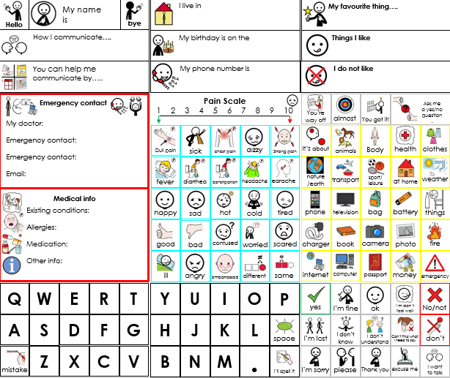

Figure 23: CommuniKate 20 ICE card

# Searching for Vocabulary in CommuniKate

To search for vocabulary in CommuniKate use PowerPoint. Go to Edit – Find, or ‘Find’ in the top right corner of the page and type in the word you are looking for it will then take you to the location of the word you want. See Figure 24 for step by step pictures.

1. 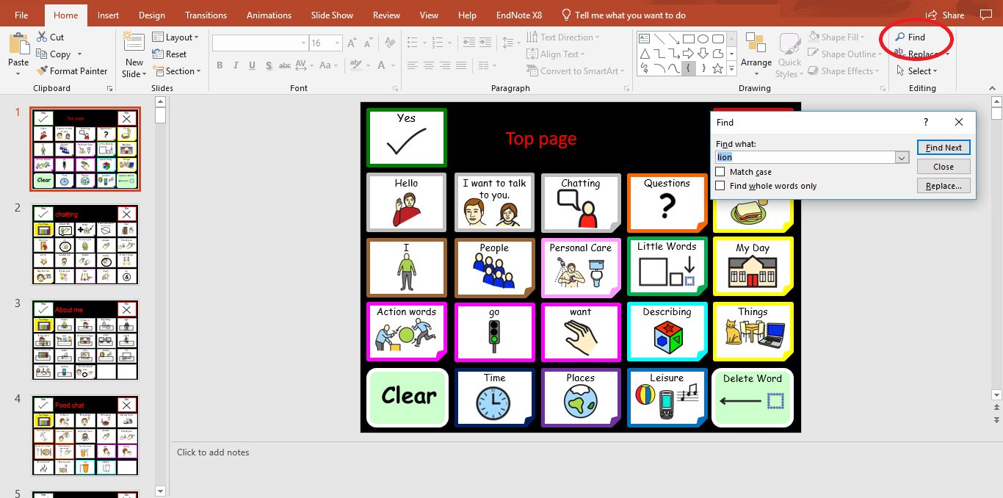
2. 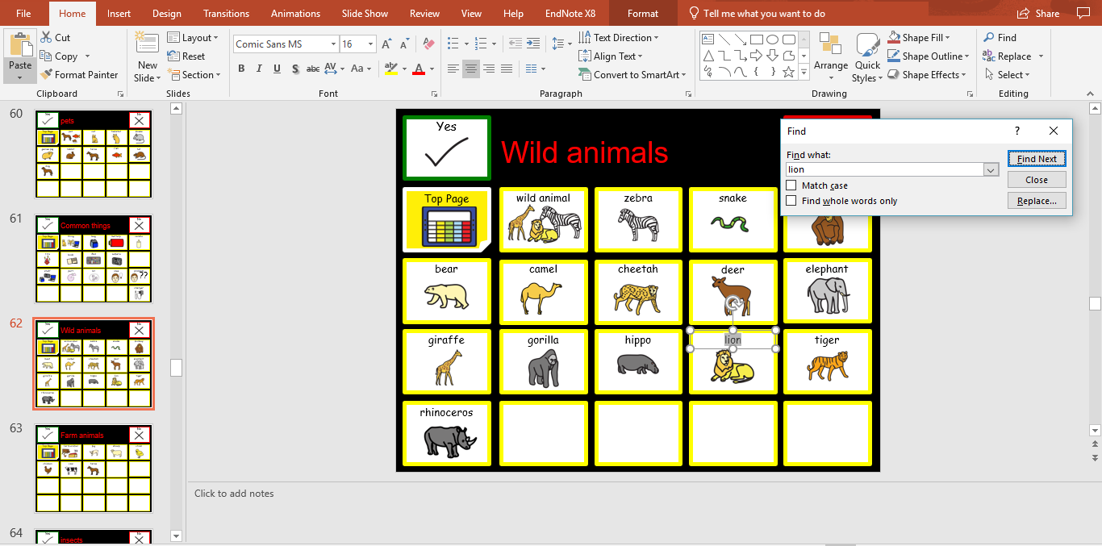

Figure 24: Step by step guide to finding vocabulary in CommuniKate on PowerPoint

# Translations

CommuniKate 20 and CommuniKate 12 are both fully available in the English Language. Unfortunately, since English is the only language of both Joe and Kate, we were unable to create translated versions of CommuniKate. Thanks to some excellent multilingual volunteers, CommuniKate has begun to become global. See <https://equalitytime.github.io/CommuniKate/translation.html> for these translations.

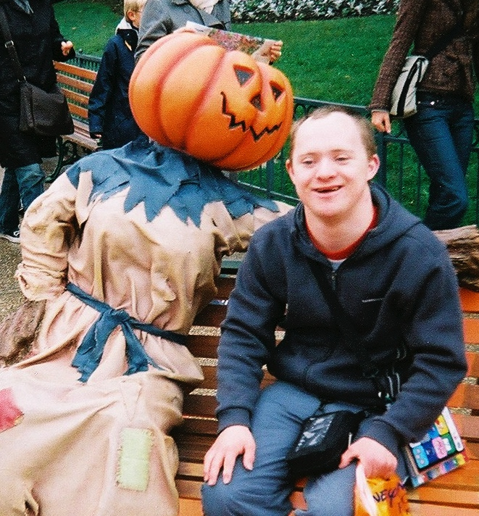

Figure 25: Kate’s brother at Disneyland Paris with CommuniKate translated into French.

We would love to have CommuniKate translated into many other languages. The more people that help us with translations and making the page set make sense for local people, the more people we can help globally! If you are interested in translating CommuniKate into a different language, please read the below information and visit [this](https://equalitytime.github.io/CommuniKate/translation.html) website.

***Translating a page set***

We use PowerPoint to make the page sets because it is a common program that lots of people can access. To make a local version of CommuniKate, you only have to download the PowerPoint file, and change the labels (and some of the pictures) so that they make sense in the local language.

You should also take out symbols that are don’t help people in the local language: for example, CommuniKate has a lot of British and American foods that might never be eaten in the local environment, so translators often change these for more helpful words.

Once you’ve made your changes please send it to us, so we can add it to our set - then many other people can make use of your work! All of our files work with the Open Voice Factory, and that site has many videos showing how to add pictures and special commands. You can also use the upload page with your files to see what the final version will look like!

***Translating a page set***

We use PowerPoint to make the page sets because it is a common program that lots of people can access. To make a local version of CommuniKate, you only have to download the PowerPoint file, and change the labels (and some of the pictures) so that they make sense in the local language.

You should also take out symbols that are don’t help people in the local language: for example, CommuniKate has a lot of British and American foods that might never be eaten in the local environment, so translators often change these for more helpful words.

Once you’ve made your changes please send it to us, so we can add it to our set - then many other people can make use of your work! All of our files work with the Open Voice Factory, and that site has many videos showing how to add pictures and special commands. You can also use the upload page with your files to see what the final version will look like!

***Translating a page set***

We use PowerPoint to make the page sets because it is a common program that lots of people can access. To make a local version of CommuniKate, you only have to download the PowerPoint file, and change the labels (and some of the pictures) so that they make sense in the local language.

You should also take out symbols that are don’t help people in the local language: for example, CommuniKate has a lot of British and American foods that might never be eaten in the local environment, so translators often change these for more helpful words.

Once you’ve made your changes please send it to us, so we can add it to our set - then many other people can make use of your work! All of our files work with the Open Voice Factory, and that site has many videos showing how to add pictures and special commands. You can also use the upload page with your files to see what the final version will look like!

***Translating a page set***

We use PowerPoint to make the page sets because it is a common program that lots of people can access. To make a local version of CommuniKate, you only have to download the PowerPoint file, and change the labels (and some of the pictures) so that they make sense in the local language.

You should also take out symbols that are don’t help people in the local language: for example, CommuniKate has a lot of British and American foods that might never be eaten in the local environment, so translators often change these for more helpful words.

Once you’ve made your changes please send it to us so we can add it to our set - then many other people can make use of your work! All of our files work with the Open Voice Factory, and that site has many videos showing how to add pictures and special commands. You can also use the upload page with your files to see what the final version will look like!

***Translating a page set***

We use PowerPoint to make the page sets because it is a common program that lots of people can access. To make a local version of CommuniKate, you only have to download the PowerPoint file, and change the labels (and some of the pictures) so that they make sense in the local language.

You should also take out symbols that are don’t help people in the local language: for example, CommuniKate has a lot of British and American foods that might never be eaten in the local environment so translators often change these for more helpful words.

Once you’ve made your changes please send it to us so we can add it to our set - then many other people can make use of your work! All of our files work with the Open Voice Factory, and that site has many videos showing how to add pictures and special commands. You can also use the upload page with your files to see what the final version will look like!

***Translating a page set***

We use PowerPoint to make the page sets because it is a common program that lots of people can access. To make a local version of CommuniKate, you only have to download the PowerPoint file, and change the labels (and some of the pictures) so that they make sense in the local language.

You should also take out symbols that are don’t help people in the local language: for example, CommuniKate has a lot of British and American foods that might never be eaten in the local environment so translators often change these for more helpful words.

Once you’ve made your changes please send it to us so we can add it to our set - then many other people can make use of your work! All of our files work with the Open Voice Factory, and that site has many videos showing how to add pictures and special commands. You can also use the upload page with your files to see what the final version will look like!

***Translating a page set***

We use PowerPoint to make the page sets because it is a common program that lots of people can access. To make a local version of CommuniKate, you only have to download the PowerPoint file, and change the labels (and some of the pictures) so that they make sense in the local language.

You should also take out symbols that are don’t help people in the local language: for example, CommuniKate has a lot of British and American foods that might never be eaten in the local environment so translators often change these for more helpful words.

Once you’ve made your changes please send it to us so we can add it to our set - then many other people can make use of your work! All of our files work with the Open Voice Factory, and that site has many videos showing how to add pictures and special commands. You can also use the upload page with your files to see what the final version will look like!

# Further Information

* ACE Centre are experts in AAC and Assistive Technology, they offer specialist services that include, assessment, training and recourses[8].
* Communication Matters is a UK-wide organisation committed to supporting people of all ages who find communication difficult because they have little or no clear speech. They have a list and details of all AAC Assessment Services in the UK, and other AAC related information[9].
* PrAACtical AAC's Mission: To improve the level of AAC services available to individuals with significant communication challenges by supporting speech-language pathologists and other interested stakeholders[10].
* The International Society for Augmentative and Alternative Communication (ISAAC) works to improve the lives of children and adults who use AAC. ISAAC’s vision is that AAC will be recognized, valued and used throughout the world. ISAAC’s mission is to promote the best possible communication for people with complex communication needs[11].
* 1 Voice – Communicating Together, takes a family and social perspective on communication and recognises the great need for adult role models to inspire children and families alike. 1Voice promotes families supporting each other to overcome the isolation that being unable to speak can bring[12].
* Publications such as Other Ways of Speaking – The communication trust, you can download a copy of for free[13].
* Tracy Kovatch: A continuum of learning for People using Augmentative and Alternative Communication Systems.
* Gail Van Tatenhove’s Website[14].

# CommuniKate Online!

This section gives an overview of how the standard version of CommuniKate can be accessed online. Not only does this allow users, SLTs and members of the care network to examine the layout and style without any inconvenience, but it is useful in its own right for AAC users.

## What

If you visit http://www.theopenvoicefactory.org/ you will find a fully responsive version of the CommuniKate page sets. There is an option for a demo use, as seen in Figure 26, but it also allows for modifications to be made to the CommuniKate page sets and uploaded, creating a personalised, online, voice output communication device that works across all platforms.



Figure 26: A screenshot of the online demo version of The Open Voice Factory running a CommuniKate 20 page set.

See the Open Voice Factory manual for more information on the features of this online software.

# Rights and Licences

Through the development of CommuniKate we have put a lot of time and effort into making sure that the CommuniKate page sets could be used freely, easily, and legally wherever anyone wanted to use it. Our goal is to remove the barriers that AAC-users face, rather than add to them. This section discusses the licences used within the project, how they affect you, and why we choose them.

## Icons

We use the Mulberry symbol set, available from <https://mulberrysymbols.org/>. The Mulberry symbol set is a large (currently includes over 3,100 symbols) symbol set that is notable for being released under a **Creative Commons BY-SA** licence. The Creative Common licences are a set of licences used commonly in a wide range of situations (for example, editors to Wikipedia release their contribution under a Creative Commons licence). In this case the Mulberry symbol set has the following terms.

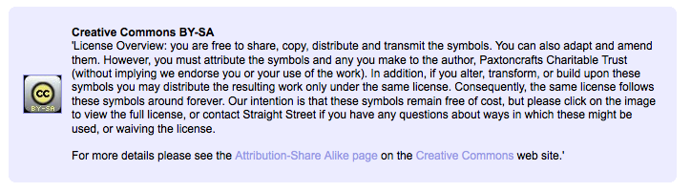

Figure 26: Licencing Screenshot from http://straight-street.org/

It is clear that the existence of the Mulberry Symbol set made CommuniKate possible. If there had NOT been a symbol set with the Creative Commons licence then we would have had to pay for a licence for a more established symbol set, and, more importantly, users of the page set would also have been obliged to pay a licence fee to us the CommuniKate page set.

During the creation of CommuniKate, we found ourselves modifying a wide range of symbols so that they more accurately depicted the semantics that we wanted to put across. We have gladly sent those new icons back to Mulberry to add to the symbol set. This sort of activity is, in its own right, an excellent argument for the use of free licences. As the licence terms specify, we release our modified icons under the same licence.

So, you can use any icon you find in CommuniKate for free, as long as it fits within the original Mulberry licence above.

## Page set

The icons, of course, are not the only intellectual property within an AAC package. Designing a page set, partitioning concepts into pages, ensuring consistency, scaffolding the right amount of support without restricting and enabling the user to make the fullest use of this all require significant expertise, and experience, particularly when designing a system as widely used as CommuniKate. This is, of course, one of the reasons why major AAC companies aggressively promote their products as much on the value of the page set as the capabilities of an individual AAC device design.

We believe that communication is a fundamental human right and so the CommuniKate page sets are also released under a creative commons licence. They can be used freely by any user who wants to try it, distributed by any SLT who wants to recommend it, and used in any college or school can make use of it. Entirely for free.

We do place some restrictions on the use of the page sets, which are carefully chosen to only affect situations where we believe there is a risk of the exploitation of AAC users.

To give some very quick examples of what fair use is:

* If a user, or their family downloads and uses a CommuniKate page set then we are absolutely happy, that’s entirely the point.
* If a for-profit AAC company releases it as a free download on their website without giving us any money, then we are again, absolutely fine with that. (Although it’s polite to mail us first).
* If a for-profit AAC company releases (a modified version) of CommuniKate, but with a different name, no licence release, or without credit to the creators, then we are **NOT** fine with that and that would be copyright theft. This is because the AAC community is a ‘slow information’ community and this runs a serious risk of users not being made aware of the range of free solutions available.
* If a for-profit AAC company sells a device that has CommuniKate installed on it, then we are happy with that (providing it is right for the end user).
* If a for-profit AAC company charges an extra £30 to have CommuniKate installed on a sold device, then we are NOT fine with that, and that would be copyright theft.

As a result, CommuniKate 20 and CommuniKate 12 are released under the Creative Commons Attribution-NonCommercial 4.0 International License. To view a copy of this license, visit <http://creativecommons.org/licenses/by-nc/4.0/> or send a letter to: Creative Commons, 444 Castro Street, Suite 900, Mountain View, California, 94041, USA.

## Screenshots

Taking screenshots of content on an AAC device turns out to be legally quite tricky. The problem is that the *graphical* *design of AAC software itself* is covered under legal protection, so if I design my own page on a commercial AAC device, using my own pictures that I’ve taken with my own camera, I still would be violating copyright if I were to share.

CommuniKate is designed to work around this. All screenshots shown in this manual and used on the online version of CommuniKate were generated in PowerPoint first. Because the files are a product of PowerPoint rather than a software program themselves, we can freely use them.

## 

Quick Aside…

This screenshot-centric approach was a very purposeful design decision. CommuniKate is designed to support extension and the Open Voice Factory in particular was designed to make it quick and easy. For people who have downloaded a copy of the Open Voice Factory and have it running locally – adding new pages is a simple as designing it in PowerPoint, and then adding the slide (as an image) to the Open Voice Factory folder with a file containing the intended utterances.

## This Manual

Like CommuniKate itself, this manual is released under the Creative Commons Attribution-NonCommercial 4.0 International License. To view a copy of this license, visit <http://creativecommons.org/licenses/by-nc/4.0/> or send a letter to: Creative Commons, 444 Castro Street, Suite 900, Mountain View, California, 94041, USA. This means that you can happily copy large chunks of it in handouts, essays, and other media as long as you mention the original source.

# Future Plans

We are always working to continue to improve CommuniKate for its users. Given that the development is open access, we would love to hear from people willing to help us with any of these directions, or people who would like to suggest their own.

# 

# Appendices

## Testimonials

This section includes a selection of testimonials from a wide range of the AAC community. We are so very proud of the wonderful things that people have had to say.

*“My sister “Emily” has used a communication aid with CommuniKate for years now. Most importantly it means that she has a voice. Although she communicates using her voice in her own way, this cannot always be understood and to those who haven't learnt to speak, "Emily's language" it can be difficult and frustrating for everyone, especially her. Having CommuniKate means that she can be more independent, Emily can ask for something in a shop, tell someone what she would like to eat, say when something hurts or that she doesn't like something. Chatting to her on the phone is easier, she uses lots of actions and mining which cannot be seen, using CommuniKate means that Emily can still tell me what she wants to with a little less guess work of what actions she might be doing 100 miles away! Having a CommuniKate means that I can worry a little less because Emily has a way of communicating with others.”*

“Emily”'s big sister

*“Many of my adult clients with learning difficulties have more to say than a few pre-stored phrases – but don’t have the linguistic skills to use semantic compaction or a grammatically based language pack.*

*CommuniKate fills that gap, by providing messages from different themes and categories, giving users the ability to communicate for a range of functions that are meaningful to them, both personal and social.*

*I have seen several users who had previously been reluctant to use AAC grow in confidence to initiate their own ideas and observations as a result of using CommuniKate”.*

Alison Carpenter, Clinical Lead SLT

# ***About the Authors***

*“Our son began using CommuniKate 20, 11 years ago. Before that he used his own version of Makaton, mime, facial expressions, pointing and the odd unintelligible, whispered word. This was only useful to those who knew him well; others found him extremely difficult to understand.*

*He began with a low-tech CommuniKate 20 book that, he still occasionally uses today. It showed us that he could find his way around the pages and select what he wanted to say. This was not totally satisfactory as we had to be patient and wait for him to turn all the pages as well as look at what he was pointing at, as there was no voice.*

*When he got CommuniKate 20 on his communication aid he was able to have conversations with people other than friends and family for the first time. He asked for his own pint of beer in the pub, he could tell people how he was feeling and in a restaurant say what he wanted to eat. Everyone much more easily understands him.*

*Now he is able to express his own personality and some of the frustrations that had built up because others could not always understand him have disappeared.*

*Using CommuniKate 20 he can go to work placements and do tasks, which previously were unachievable, like taking and making the tea and coffee order and chatting to people.*

*New people are able to understand him quickly, which has been a great benefit to him when moving from the family home into supported living. His staff has not needed to learn all his personal and individual signs and ways of communicating because he has been able to use CommuniKate 20 on his communication aid.*

*Life for all concerned has became much happier and less frustrating. IT’S CHANGED ALL OUR LIVES FOR THE BETTER”.*

Parents of a CommuniKate 20 user

## Kate McCallum

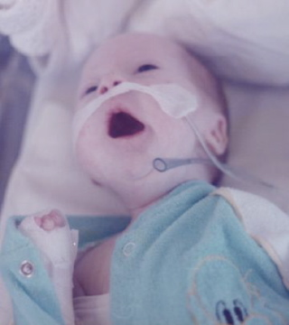I’ve lived and breathed AAC for the past 15 years professionally, working in a range of settings, an assessment centre, a SEN school, for a major AAC supplier, and currently as a trustee for the charity, 1 Voice – Communicating Together and in my day job as an AAC Technician at Beaumont College. I also qualified as an Occupational Therapist in 2013.

My journey into AAC began when I was much younger. I was 5 when my brother was born with complex special needs. As I was growing up each time I threw a penny in a wishing well or blew the candles out on my birthday cake I would wish the same wish, it was that one day my brother would speak.

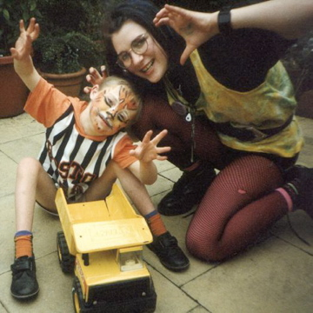My brother’s speech is unintelligible to those who do not know him, due to a physical and intellectual disability. He has difficulties with both expressive and receptive language, but he has always had a desire to communicate and will go to great lengths to try to make himself understood. All of his life I have witnessed his frustration trying to get his message across. When his attempts to communicate have been ignored or misunderstood he has, had periods when he has isolated himself and retreated from normal everyday activity or displayed what is perceived as challenging behaviour, as a result of watching this day in day out I am a strong believer that all behaviour is communication.

Despite being in special education and services all his life he was only ever given limited access to AAC, in the form sign language. Age 2 his SLT recommended he learn Makaton, and this gave him an avenue to communication and supports his understanding of the spoken word. Today Makaton remains a valid and valuable communication strategy for him however his idiosyncratic communication behaviours, mean unless you know him really well you can’t understand what he is saying, and he has to rely on someone interpreting his communication attempts. This was a huge barrier to him communicating outside of his immediate circle of family and friends who knew him really well.

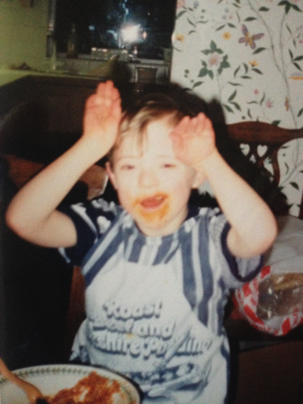I made him a communication board on the back of an old cereal packet with pictures cut out of an old Argos catalogue. He used it well and when he was 15 I use the same sort of idea to make him is his first communication book. Neither of these low - tech strategies were effective if the person with him could not see him for example when in the back of the car.

In 1995 I left school and went volunteering at an outdoor centre that catered for people with disabilities. I met a lady who was using an ORAC some years later the same lady was using a DeltaTalker with LLL. I knew that this was to cognitively demanding for him because of his learning difficulties. However, the concept of pressing a button and getting a word out was so exciting I spent the next few years trying to find out what these talking boxes were and working out a how something like this could work for him.

In 2001 my brother got his first communication aid, but it did not have a language pack that was appropriate for him, so I wrote one. This was the beginning of CommuniKate. He progressed so quickly that soon 12 buttons did not give him the access to the volume of vocabulary he needed. Hence, CommuniKate 20 was written.

## Joe Reddington

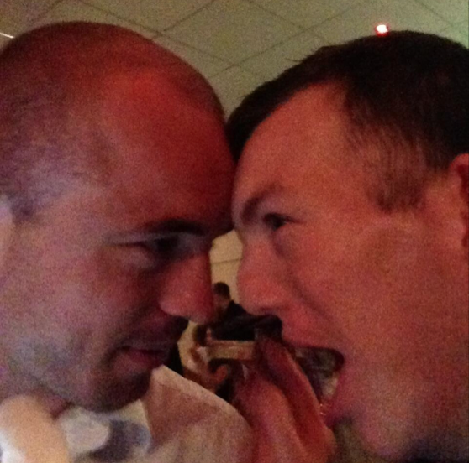

Figure 23: Richard getting Joe's attention. Possibly vice-versa

I’ve been working on AAC-related things for some years now, sometimes paid to do it, sometimes not. In many ways my little brother is very lucky in terms of AAC, he’s surrounded by technically competent people and has a well-developed and dedicated care network. There is no question that AAC completely changed his life (via Kate, who was the tech who made it work for him and Alison his SLT) and I’d like to make sure that more people get the same opportunity. That’s one of the reasons I built things like [the Domesday Dataset](http://joereddington.com/aac-and-the-domesday-dataset/), which revealed a horrific postcode lottery in AAC provision and its one of the major reasons I’ve been working with Kate to bring CommuniKate 20 into the public view. In 2014 I left behind a university career to start a charity that, amongst other things, hopes to make, AAC devices available to all that need them.

# References

Banajee, M., Dicarlo, C., & Stricklin, S. B. (2003). Core Vocabulary Determination for Toddlers. *Augmentative and Alternative Communication, 19*(2), 67-73.

Binger, C., & Light, J. (2007). The effect of aided AAC modeling on the expression of multi-symbol messages by preschoolers who use AAC*. Augmentative and Alternative Communication, 23,* 30–43.

Dada, S., & Alant, E. (2009). The effect of aided language stimulation on vocabulary acquisition in children with little or no functional speech. *American Journal of Speech-Language Pathology, 18,* 50–64.

Deruyter, F., McNaughton, D., Caves, K., Nelson Bryen, D., & Williams, M. B. (2007). Enhancing AAC connections with the world. *Augmentative and Alternative Communication*, *23*(3), 258–270.

Dukhovny, E. and Gahl. S. (2014). Manual motor-plan similarity affects lexical recall on a speech-generating device: implications for AAC users. *Journal of Communication Disorders, 48*, 52-60.

Goossens, C., Crain, S., & Elder, P. (1992). Engineering the Classroom Environment for Interactive Symbolic Communication. *Southeast Aug Comm Conference Publications,* Birmingham, Alabama.

Halloran, J., & Emerson, M., (2006). LAMP: Language Acquisition Through Motor Planning. Wooster OH: Prentke Romich Company.

Kent-Walsh, J., & Light, J. (2003). General education teachers’ experiences with inclusion of students who use augmentative and alternative communication. *Augmentative and Alternative Communication, 19,* 104–124.

Kucera, H. & Francis, W. (1967). *Computational analysis of present day American English.* Providence, RI: Brown University Press.

Lesher, G. W., Moulton, B. J., Rinkus, G., & Higginbotham, J. (2000a). A universal logging format for augmentative communication. Accessed from <http://citeseerx.ist.psu.edu/viewdoc/download?doi=10.1.1.24.2047&rep=rep1&type=pdf>

Lesher, G. W., Moulton, B. J., Rinkus, G., & Higginbotham, J. (2000b). Logging and analysis of augmentative communication*. In RESNA Annual Conference.* Orlando Florida.

Light, J., & McNaughton, D. (2014). Communicative competence for individuals who require augmentative and alternative communication: A new definition for a new era of communication?. *Augmentative and Alternative Communication*, *30*, 1-18.

Millar, D. C., Light, J. C., & Schlosser, R. W. (2006). The impact of augmentative and alternative communication intervention on the speech production of individuals with developmental disabilities: A research review. *Journal of Speech, Language, and Hearing Research, 49*(2), 248–264.

Preston, D. & Carter, M. (2009). A review of the efficacy of the Picture Exchange Communication System intervention. *Journal of Autism and Developmental Disorders,* *39* (10), 1471–1486.

Reddington, J. (2013). The domesday dataset: linked open data in disability studies. *Journal of Intellectual Disabilities*, *17*(2), 107-121.

Schlosser, R. W. & Lloyd, L. L. (2003). Effects of AAC on Natural Speech Development. In Ralf W. Schlosser (Ed.) *The Efficacy of Augmentative and Alternative Communication: Toward Evidence-Based Practice*. USA: Academic Press.

Schlosser, R. W. & Wendt, O. (2008). Effects of augmentative and alternative communication intervention on speech production in children with autism: a systematic review. *American Journal of Speech-Language Pathology,* *17*(3), 212–230.

Sennott, S.C., Light, J., & McNaughton, D. (2016). AAC modeling intervention research review. *Research and Practice for Persons with Severe Disabilities, 41*, 101–15.

Shepherd, T. A., Campbell, K.A., Renzoni, A.M., & Sloan, N. (2009). Reliability of speech generating devices: A 5-year review. *Augmentative and Alternative Communication,* *25*(3), 145-153.

Thistle, J., Holmes, S., Horn, M. & Reum, A. (2018). Consistent Symbol Location Affects Motor Learning in Preschoolers Without Disabilities: Implications for Designing Augmentative and Alternative Communication Displays. *American Journal of Speech-Language Pathology*, 27(3) 1010-1017

Van Tatenhove, G. (2011). Core Vocabulary List for Students with Intellectual Disabilities. Accessed from <http://www.vantatenhove.com/files/papers/VocabularyLists/CoreVocabListSIDs.pdf>

1. <http://communikate.equalitytime.co.uk/>

   2 <http://www.theopenvoicefactory.org/>
2. Kate and Joe. Obviously.
3. http://communikate.equalitytime.co.uk/
4. We mentioned GBBO in the 2014 version of this manual, when the show was ‘only’ four seasons long. Writing in 2022 it feels like we picked a winner.
5. For UK and US readers the lesson plan option might seem strange, but many countries have centralised lesson plans, and we have spoken with developers of native-language AAC-apps that exploit this to give AAC users timely and relevant information.
6. See the Open Voice Factory Manual for more details.
7. Joe’s brother’s device was once left on the roof of the car, fell off, and then was run over. It continued to work. We would like to applaud the construction of the AdVOCAte.

   8 <http://equalitytime.co.uk/4604/2015/01/12/step-by-step-making-a-low-tech-communication-book/>
8. <http://acecentre.org.uk/>
9. <http://www.communicationmatters.org.uk/>
10. <http://praacticalaac.org/>
11. <https://www.isaac-online.org/english/home/>
12. <http://www.1voice.info/>
13. <https://www.thecommunicationtrust.org.uk/resources/resources/resources-for-parents/other-ways-of-speaking.aspx>
14. <http://www.vantatenhove.com/>